NAME: ARCHANA DEVI.P
REG NO: 192521192
COURSE: DESIGN ANALYSIS OF ALGORITHM
CODE: CSA0613
ASSIGNMENT: CO5_AT_1

QUESTION:
Q7. Sudoku Solver (Backtracking / NP-Complete Problem)
A partially filled 9×9 Sudoku grid must be completed such that each row, column, and
subgrid contains unique numbers from 1 to 9. Clearly define all constraints and input
conditions. Analyze how constraints interact and restrict possible values. Develop a
backtracking-based solution to fill the grid. Apply constraint propagation and pruning
techniques effectively. Justify the correctness of your approach and discuss performance
challenges.

1. Aim
To develop and implement a Sudoku Solver using the Backtracking algorithm with constraint checking and pruning techniques to efficiently solve a partially filled 9×9 Sudoku grid.
2. Problem Statement
A Sudoku puzzle consists of a 9×9 grid divided into nine 3×3 subgrids. Some cells contain predefined numbers, while the remaining cells are empty. The objective is to fill all empty cells with numbers from 1 to 9 while satisfying the Sudoku constraints.
The problem requires finding a valid arrangement such that:
- Every row contains numbers from 1 to 9 without repetition.
- Every column contains numbers from 1 to 9 without repetition.
- Every 3×3 subgrid contains numbers from 1 to 9 without repetition.
The Sudoku Solver uses a backtracking approach, where possible values are placed into empty cells one by one. If a value violates any constraint, it is rejected. If a selected value eventually leads to an unsolvable configuration, the algorithm backtracks and tries another possible value.

3. Constraints and Input Conditions
3.1 Input Conditions
The input must satisfy the following conditions:
- The Sudoku board must contain 9 rows and 9 columns.
- Each cell must contain a value between 0 and 9.
- The value 0 represents an empty cell.
- Values from 1 to 9 represent fixed or already assigned numbers.
- The initially provided numbers must not violate Sudoku rules.
3.2 Sudoku Constraints
For every number placed in a cell:
Row Constraint
- The same number must not appear more than once in a row.
Column Constraint
- The same number must not appear more than once in a column.
Subgrid Constraint
- The same number must not appear more than once in the corresponding 3×3 subgrid.

4. Analysis of Constraint Interaction
The Sudoku constraints interact strongly with one another. When a number is placed in an empty cell, it affects:
- The possible values of other empty cells in the same row.
- The possible values of other empty cells in the same column.
- The possible values of other empty cells in the same 3×3 sub grid.
For example, if the number 5 is placed in a cell:
- No other empty cell in the same row can contain 5.
- No other empty cell in the same column can contain 5.
- No other empty cell in the same 3×3 box can contain 5.
Therefore, every assignment reduces the set of possible values for related cells. This restriction is known as constraint propagation.
5. Algorithm Used
Backtracking Algorithm
Backtracking is a systematic search technique used to solve constraint satisfaction problems.
The algorithm works as follows:
- Find an empty cell in the Sudoku board.
- Try numbers from 1 to 9.
- Check whether the number satisfies all Sudoku constraints.
- If valid, place the number in the cell.
- Recursively solve the remaining empty cells.
- If no solution is possible, remove the number and try another value.
- Continue until the puzzle is solved.
6. Pseudocode
FUNCTION solveSudoku(board):
Find an empty cell
IF no empty cell exists:
RETURN True
FOR number from 1 to 9:
IF number is valid in the current cell:
Place number in the cell
IF solveSudoku(board) is True:
RETURN True
Remove the number from the cell
RETURN False
7. Program
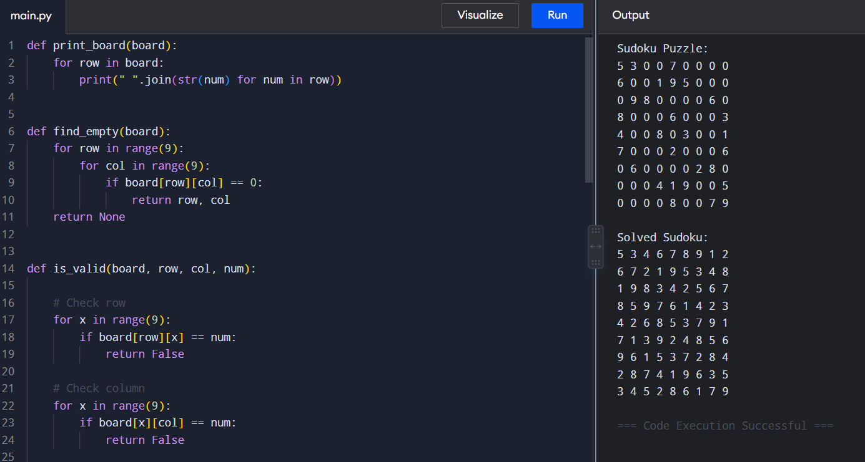
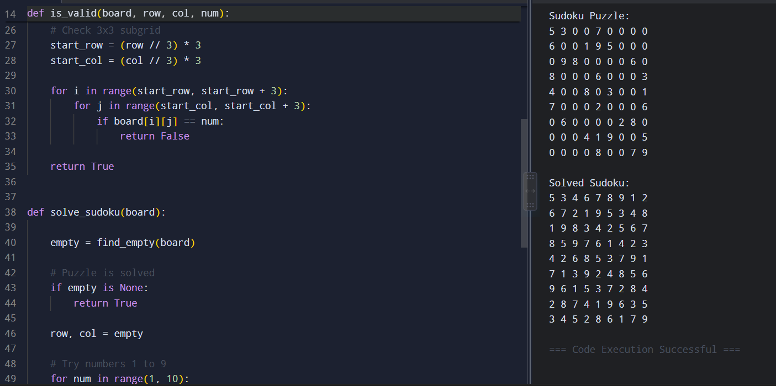
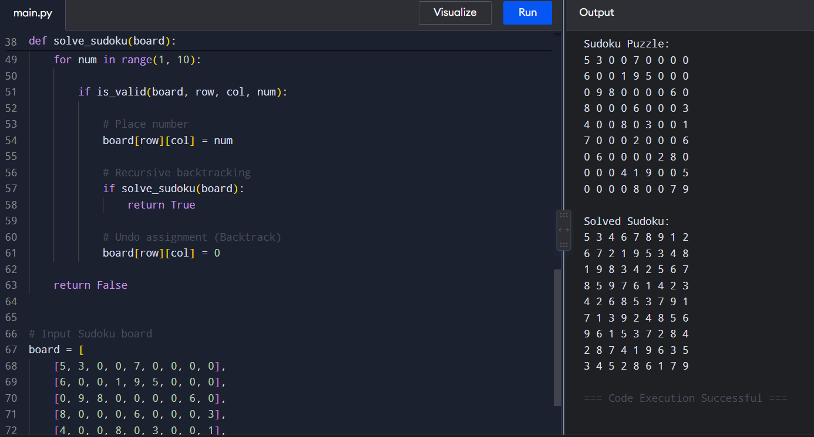
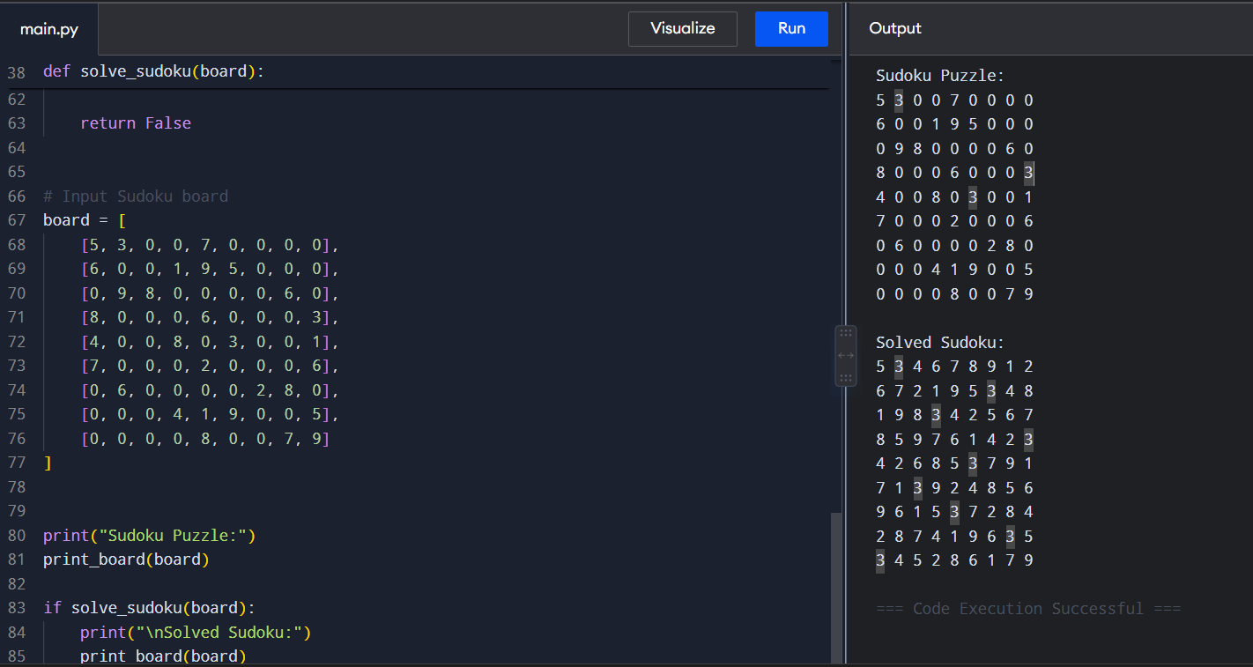

9. Constraint Propagation and Pruning
Constraint Propagation
Constraint propagation reduces unnecessary search by checking the effects of each assignment immediately.
When a number is placed:
- The row restricts duplicate values.
- The column restricts duplicate values.
- The 3×3 subgrid restricts duplicate values.
Only values satisfying all three conditions are considered valid.
Pruning
Pruning eliminates invalid solution paths early.
For example:
Try placing 1 → Invalid → Prune
Try placing 2 → Invalid → Prune
Try placing 3 → Valid → Continue

If a later cell cannot be assigned any valid value:
Dead End
↓
Undo previous assignment
↓
Try another value

This significantly reduces the number of configurations that must be explored.
10. Correctness of the Approach
The algorithm is correct because:
- Only valid values are inserted
Before placing a number, the algorithm checks the row, column, and 3×3 subgrid constraints.
- All possible valid choices are explored
If the current choice does not lead to a solution, the algorithm tries other possible values.
- Backtracking removes incorrect choices
When a dead end is reached, the algorithm restores the cell to empty and returns to the previous decision.
- The algorithm terminates when all cells are filled
A completed board satisfies all Sudoku constraints because every placement has been validated.
Therefore, if a solution exists, the algorithm can find a valid solution through systematic exploration.

11. Complexity Analysis
Let n be the number of empty cells.
In the worst case, each empty cell may try up to 9 possible values.
Time Complexity
O(9^n)
where n is the number of empty cells.
The actual running time is generally lower because constraint checking and pruning eliminate many invalid possibilities.
Space Complexity
The recursive function can go as deep as the number of empty cells.
O(n)
For a standard Sudoku board:
Maximum recursion depth ≤ 81
12. Performance Challenges
The main performance challenge is the potentially large search space.
Challenges
- A Sudoku board may contain many empty cells.
- Incorrect choices can lead to deep recursive searches.
- A basic backtracking algorithm may explore many possibilities before finding a solution.
- Difficult Sudoku puzzles require more recursive calls.
Improvements
The performance can be improved using:
- Constraint propagation
- Early pruning
- Minimum Remaining Values (MRV) heuristic
- Forward checking
- Efficient candidate selection
The MRV technique selects the empty cell with the fewest possible values first. This can reduce the number of unnecessary recursive calls.
13. Result
- The Sudoku Solver was successfully implemented using the Backtracking algorithm. The program accepts a partially filled 9×9 Sudoku grid and systematically fills empty cells with valid numbers. Each assignment is verified against row, column, and 3×3 subgrid constraints.
- Constraint propagation and pruning help eliminate invalid possibilities early. When a chosen value leads to a dead end, the algorithm performs backtracking and explores alternative values. The program successfully produces a valid completed Sudoku solution.
14. Conclusion
- The Sudoku Solver demonstrates the application of backtracking to a constraint satisfaction problem. The algorithm recursively explores possible values while ensuring that all Sudoku rules are satisfied. Constraint checking prevents invalid assignments, while pruning reduces unnecessary exploration.
- Although Sudoku belongs to a class of computationally difficult problems and the worst-case search complexity can be high, backtracking combined with constraint propagation is effective for solving standard Sudoku puzzles. The implementation clearly demonstrates recursion, constraint satisfaction, pruning, and systematic search.

